Nama : Silfiana Dwi Nabiilah
NIM : 221344028
Kelas : 1A TNK
Membuktikan hasil penyederhanaan persamaan dengan mengimplementasikan persamaan tersebut pada rangkaian logika.
- Penyederhanaan persamaan menggunakan aljabar Boolean & Teorema De Morgan
- Impelementasikan persamaan berikut menggunakan gate dasar pada Proteus.
- Sederhanakan persamaan tersebut, kemudian implementasikan rangkaian dari
hasil penyederhanaan tersebut pada Proteus.
- Uji hasil dari kedua rangkaian tersebut menggunakan tabel kebenaran.

- $F=AB+A\left(B+C\right)+B(B+C)$ = $AC+B$
Jawab :
$$F=AB+A\left(B+C\right)+B\left(B+C\right)$$
$$F=AB+AB+AC+BB+BC$$
$$F=AB+AC+B+BC$$
$$F=AC+B$$
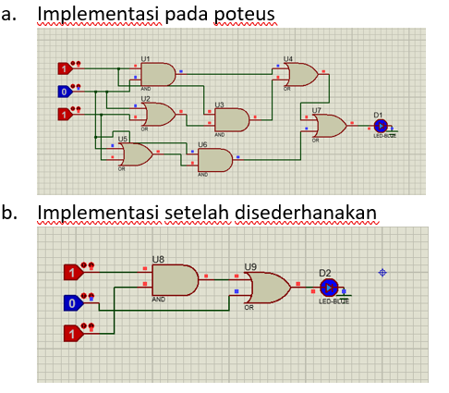
Rangkaian ruas kiri dan ruas kanan
Input |  |  | Output
A | B | C | $$AB+A\left(B+C\right)+B(B+C)$$ | $$F=AC+B$$
0 | 0 | 0 | 0 | 0
0 | 0 | 1 | 0 | 0
0 | 1 | 0 | 1 | 1
0 | 1 | 1 | 1 | 1
1 | 0 | 0 | 0 | 0
1 | 0 | 1 | 1 | 1
1 | 1 | 0 | 1 | 1
1 | 1 | 1 | 1 | 1

- $F=[A\overline{B}(C+BD)+\overline{A}\overline{B}]C$
Jawab :
$$F=[A\overline{B}(C+BD)+\overline{A}\overline{B}]C$$
$$F=A\overline{B}C+A\overline{B}BD+\overline{A}\overline{B}C$$
$$F=\overline{B}C(A+\overline{A})$$
$$F=\overline{B}C$$
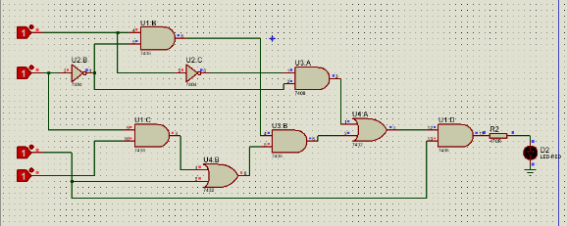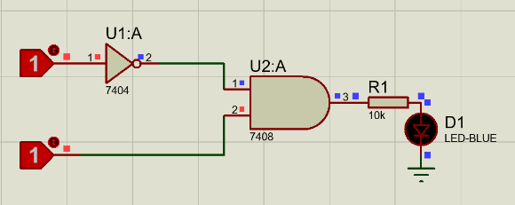
Rangkaian ruas kiri dan ruas kanan
Input |  |  |  | Output
A | B | C | D | $$[A\overline{B}(C+BD)+\overline{A}\overline{B}]C$$ | $$\overline{B}C$$
0 | 0 | 0 | 0 | 0 | 0
0 | 0 | 0 | 1 | 0 | 0
0 | 0 | 1 | 0 | 1 | 1
0 | 0 | 1 | 1 | 1 | 1
0 | 1 | 0 | 0 | 0 | 0
0 | 1 | 0 | 1 | 0 | 0
0 | 1 | 1 | 0 | 0 | 0
0 | 1 | 1 | 1 | 0 | 0
1 | 0 | 0 | 0 | 0 | 0
1 | 0 | 0 | 1 | 0 | 0
1 | 0 | 1 | 0 | 1 | 1
1 | 0 | 1 | 1 | 1 | 1
1 | 1 | 0 | 0 | 0 | 0
1 | 1 | 0 | 1 | 0 | 0
1 | 1 | 1 | 0 | 0 | 0
1 | 1 | 1 | 1 | 0 | 0

- $F= \overline{A}BC+A\overline{B}\overline{C}+ \overline{A}\overline{B}\overline{C}+A\overline{B}C+ABC$
Jawab :
$$F= \overline{A}BC+A\overline{B}\overline{C}+ \overline{A}\overline{B}\overline{C}+A\overline{B}C+ABC$$
$$F= \overline{A}BC+\overline{B}\overline{C}\left(A+\overline{A}\right)+BC(\overline{A}+A)$$
$$F= \overline{A}BC+\overline{B}\overline{C}+BC$$
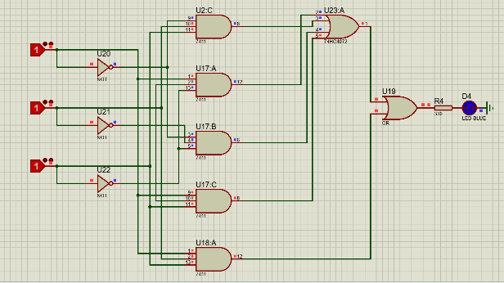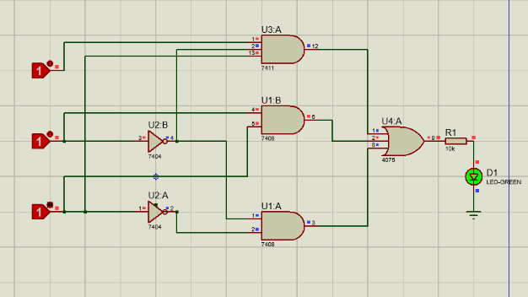
Rangkaian ruas kiri dan ruas kanan
Input |  |  | Output
A | B | C | $$\overline{A}BC+A\overline{B}\overline{C}+ \overline{A}\overline{B}\overline{C}+A\overline{B}C+ABC$$ | $$\overline{A}BC+\overline{B}\overline{C}+BC$$
0 | 0 | 0 | 1 | 1
0 | 0 | 1 | 0 | 0
0 | 1 | 0 | 0 | 0
0 | 1 | 1 | 1 | 1
1 | 0 | 0 | 1 | 1
1 | 0 | 1 | 1 | 1
1 | 1 | 0 | 0 | 0
1 | 1 | 1 | 1 | 1

- $F=\overline{\left(\overline{A}+B\right)+CD}$
Jawab :
$F=\overline{\left(\overline{A}+B\right)+CD}$
$$F=\left(A\overline{B}\right)(\overline{C}+\overline{D})$$
$$F=A\overline{B}\overline{C}+A\overline{BD}$$
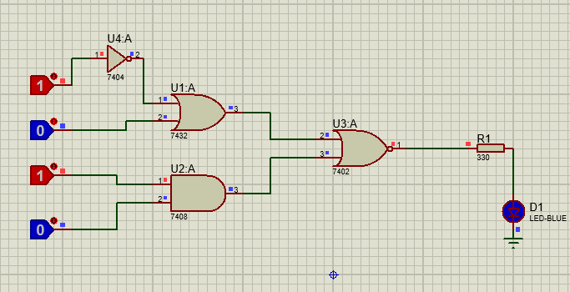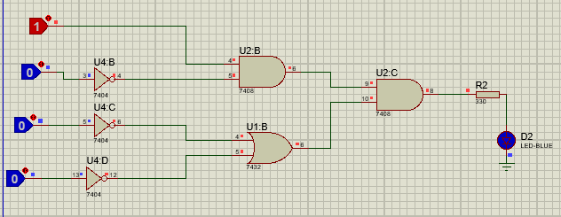
Rangkaian ruas kiri dan ruas kanan
Input |  |  |  | Output
A | B | C | D | $$\overline{\left(\overline{A}+B\right)+CD}$$ | $$A\overline{B}\overline{C}+A\overline{BD}$$
0 | 0 | 0 | 0 | 0 | 0
0 | 0 | 0 | 1 | 0 | 0
0 | 0 | 1 | 0 | 0 | 0
0 | 0 | 1 | 1 | 0 | 0
0 | 1 | 0 | 0 | 0 | 0
0 | 1 | 0 | 1 | 0 | 0
0 | 1 | 1 | 0 | 0 | 0
0 | 1 | 1 | 1 | 0 | 0
1 | 0 | 0 | 0 | 1 | 1
1 | 0 | 0 | 1 | 1 | 1
1 | 0 | 1 | 0 | 1 | 1
1 | 0 | 1 | 1 | 0 | 0
1 | 1 | 0 | 0 | 0 | 0
1 | 1 | 0 | 1 | 0 | 0
1 | 1 | 1 | 0 | 0 | 0
1 | 1 | 1 | 1 | 0 | 0

- $F=\overline{\overline{\left(\overline{A}+B+C\right)}(\overline{A\overline{B }\overline{C})}}$
Jawab :
$$F=\overline{\overline{\left(\overline{A}+B+C\right)}(\overline{A\overline{B }\overline{C})}}$$
$$F=\overline{(A\overline{BC})(\overline{A}+B+C)}$$
$$F=\left(\overline{A}+B+C\right)+(A\overline{BC})$$
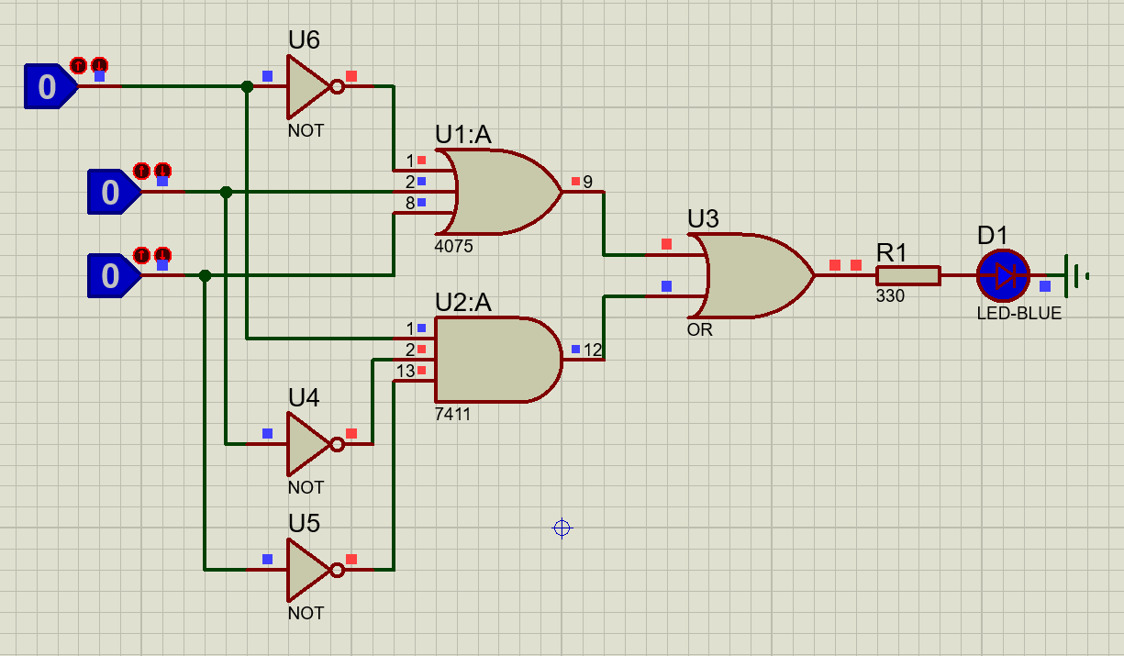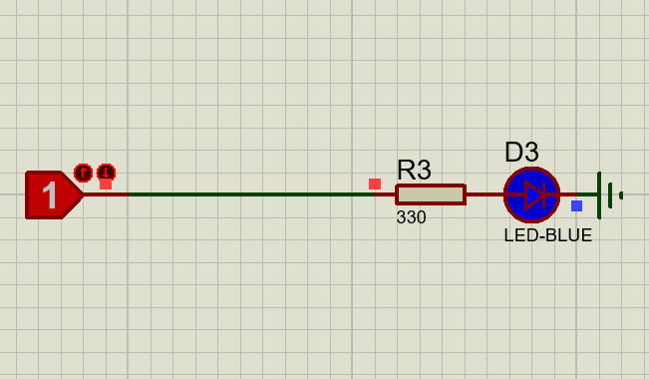
Rangkaian ruas kiri dan ruas kanan
Input |  |  | Output
A | B | C | $$\overline{\overline{\left(\overline{A}+B+C\right)}(\overline{A\overline{B }\overline{C})}}$$ | $$F=1$$
0 | 0 | 0 | 1 | 1
0 | 0 | 1 | 1 | 1
0 | 1 | 0 | 1 | 1
0 | 1 | 1 | 1 | 1
1 | 0 | 0 | 1 | 1
1 | 0 | 1 | 1 | 1
1 | 1 | 0 | 1 | 1
1 | 1 | 1 | 1 | 1

B. Implementasi Metoda Odd & Even pada rangkaian
1. Diketahui suatu rangkaian odd & even sebagai berikut :
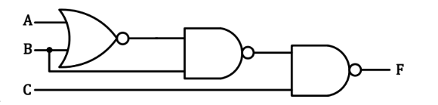
- Rangkailah rangkaian di atas pada Proteus.
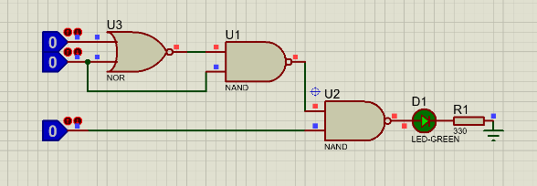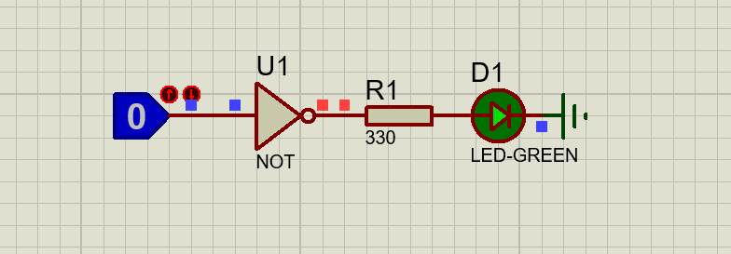
Rangkaian ruas kiri dan ruas kanan
- Tuliskan persamaan dari rangkaian di atas menggunakan metode Aljabar Boolean & Teorema De Morgan dan metode Odd & Even.
Jawab :
$$F=\left(\overline{A+B}\right)$$
$$F=\overline{\left(\overline{A+B}\right)B}$$
$$F=\overline{\left(AB\right)+\overline{B})C}$$
$$F=\overline{AB}B+\overline{C}$$
- Sederhanakan persamaan rangkaian tersebut.
Jawab :
$$F=\overline{AB}B+\overline{C}$$
$$F=\overline{C}$$
- Buktikan pengujian rangkaian tersebut pada data Uji.
Input |  |  | Output
A | B | C | $$\overline{A}\overline{B}B+\overline{C}$$ | $$\overline{C}$$
0 | 0 | 0 | 1 | 1
0 | 0 | 1 | 0 | 0
0 | 1 | 0 | 1 | 1
0 | 1 | 1 | 0 | 0
1 | 0 | 0 | 1 | 1
1 | 0 | 1 | 0 | 0
1 | 1 | 0 | 1 | 1
1 | 1 | 1 | 0 | 0

.2. Diketahui suatu rangkaian odd & even sebagai berikut :
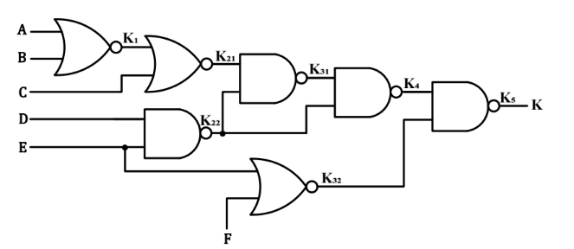
- Rangkailah rangkaian di atas pada Proteus.
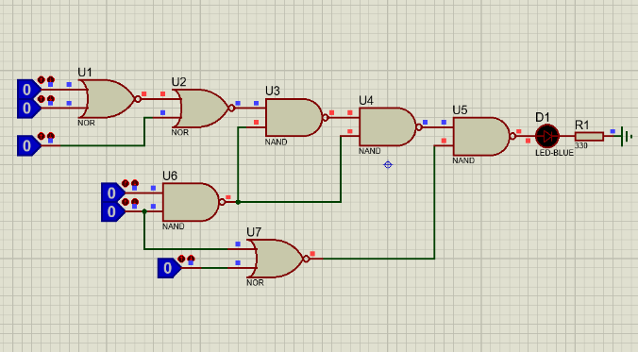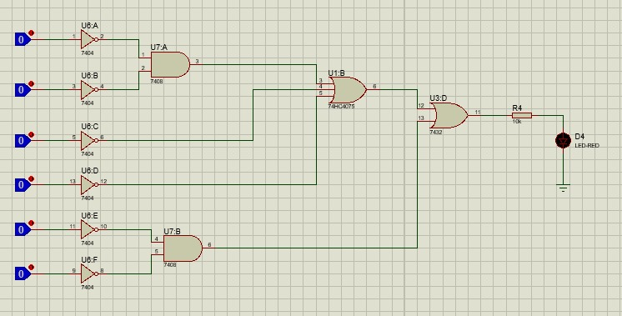
Rangkaian Ruas kiri dan Ruas kanan
- Tuliskan persamaan dari rangkaian di atas menggunakan metode Aljabar Boolean & Teorema De Morgan dan metode Odd & Even.
Jawab :
$$F=\left(\overline{AB}+C+DE\right)\left(\overline{D+E}\right)+E+F$$
- Sederhanakan persamaan rangkaian tersebut.
Jawab :
$$F=\left(\overline{AB}+C+DE\right)\left(\overline{D+E}\right)+E+F$$
$$F=\left(\overline{AB}+C+DE\right)\left(\overline{D+E}\right)+E+F$$
$$F=\overline{AB}+C+E+F$$

- Buktikan pengujian rangkaian tersebut pada data Uji.
Input |  |  |  |  |  | Output
A | B | C | D | E | F | $$\left(\overline{AB}+C+DE\right)\left(\overline{D+E}\right)+E+F$$ | $$\overline{AB}+C+E+F$$
0 | 0 | 0 | 0 | 0 | 0 | 1 | 1
0 | 0 | 0 | 0 | 0 | 1 | 1 | 1
0 | 0 | 0 | 0 | 1 | 0 | 1 | 1
0 | 0 | 0 | 0 | 1 | 1 | 1 | 1
0 | 0 | 0 | 1 | 0 | 0 | 1 | 1
0 | 0 | 0 | 1 | 0 | 1 | 1 | 1
0 | 0 | 0 | 1 | 1 | 0 | 1 | 1
0 | 0 | 0 | 1 | 1 | 1 | 1 | 1
0 | 0 | 1 | 0 | 0 | 0 | 1 | 1
0 | 0 | 1 | 0 | 0 | 1 | 1 | 1
0 | 0 | 1 | 0 | 1 | 0 | 1 | 1
0 | 0 | 1 | 0 | 1 | 1 | 1 | 1
0 | 0 | 1 | 1 | 0 | 0 | 1 | 1
0 | 0 | 1 | 1 | 0 | 1 | 1 | 1
0 | 0 | 1 | 1 | 1 | 0 | 1 | 1
0 | 0 | 1 | 1 | 1 | 1 | 1 | 1
0 | 1 | 0 | 0 | 0 | 0 | 0 | 0
0 | 1 | 0 | 0 | 0 | 1 | 1 | 1
0 | 1 | 0 | 0 | 1 | 0 | 1 | 1
0 | 1 | 0 | 0 | 1 | 1 | 1 | 1
0 | 1 | 0 | 1 | 0 | 0 | 0 | 0
0 | 1 | 0 | 1 | 0 | 1 | 1 | 1
0 | 1 | 0 | 1 | 1 | 0 | 1 | 1
0 | 1 | 0 | 1 | 1 | 1 | 1 | 1
0 | 1 | 1 | 0 | 0 | 0 | 1 | 1
0 | 1 | 1 | 0 | 0 | 1 | 1 | 1
0 | 1 | 1 | 0 | 1 | 0 | 1 | 1
0 | 1 | 1 | 0 | 1 | 1 | 1 | 1
0 | 1 | 1 | 1 | 0 | 0 | 1 | 1
0 | 1 | 1 | 1 | 0 | 1 | 1 | 1
0 | 1 | 1 | 1 | 1 | 0 | 1 | 1
0 | 1 | 1 | 1 | 1 | 1 | 1 | 1
1 | 0 | 0 | 0 | 0 | 0 | 0 | 0
1 | 0 | 0 | 0 | 0 | 1 | 1 | 1
1 | 0 | 0 | 0 | 1 | 0 | 1 | 1
1 | 0 | 0 | 0 | 1 | 1 | 1 | 1
1 | 0 | 0 | 1 | 0 | 0 | 0 | 0
1 | 0 | 0 | 1 | 0 | 1 | 1 | 1
1 | 0 | 0 | 1 | 1 | 0 | 1 | 1
1 | 0 | 0 | 1 | 1 | 1 | 1 | 1
1 | 0 | 1 | 0 | 0 | 0 | 1 | 1
1 | 0 | 1 | 0 | 0 | 1 | 1 | 1
1 | 0 | 1 | 0 | 1 | 0 | 1 | 1
1 | 0 | 1 | 0 | 1 | 1 | 1 | 1
1 | 0 | 1 | 1 | 0 | 0 | 1 | 1
1 | 0 | 1 | 1 | 0 | 1 | 1 | 1
1 | 0 | 1 | 1 | 1 | 0 | 1 | 1
1 | 0 | 1 | 1 | 1 | 1 | 1 | 1
1 | 1 | 0 | 0 | 0 | 0 | 0 | 0
1 | 1 | 0 | 0 | 0 | 1 | 1 | 1
1 | 1 | 0 | 0 | 1 | 0 | 1 | 1
1 | 1 | 0 | 0 | 1 | 1 | 1 | 1
1 | 1 | 0 | 1 | 0 | 0 | 0 | 0
1 | 1 | 0 | 1 | 0 | 1 | 1 | 1
1 | 1 | 0 | 1 | 1 | 0 | 1 | 1
1 | 1 | 0 | 1 | 1 | 1 | 1 | 1
1 | 1 | 1 | 0 | 0 | 0 | 1 | 1
1 | 1 | 1 | 0 | 0 | 1 | 1 | 1
1 | 1 | 1 | 0 | 1 | 0 | 1 | 1
1 | 1 | 1 | 0 | 1 | 1 | 1 | 1
1 | 1 | 1 | 1 | 0 | 0 | 1 | 1
1 | 1 | 1 | 1 | 0 | 1 | 1 | 1
1 | 1 | 1 | 1 | 1 | 0 | 1 | 1
1 | 1 | 1 | 1 | 1 | 1 | 1 | 1

